**LOUVER TABLE FANS:**

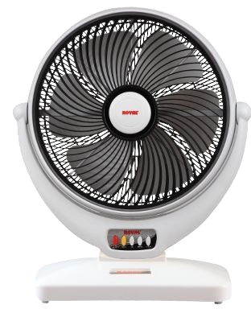

**Price: 15,500.00**

The Louver Table Fan is a versatile and compact ventilation solution, designed to provide focused airflow and cooling relief in a variety of settings. With its adjustable louver design, this fan directs airflow precisely where needed, making it perfect for offices, workstations, and other areas where targeted cooling is desired. Its compact size, quiet operation, and energy-efficient design make it an ideal choice for those seeking a convenient and effective personal cooling solution.

**Key features of louver table include:**

* **Adjustable Louvers** – Allows precise control over airflow direction.
* **Compact Design** – Space-efficient for placement on tables or desks.
* **Multiple Speed Settings** – Offers adjustable airflow levels for comfort.
* **Quiet Operation** – Runs quietly for minimal noise disruption.
* **Portable** – Lightweight and easy to move or reposition.
* **Energy Efficient** – Consumes less power for cost-effective cooling.
* **Durable Construction** – Built for long-lasting performance with sturdy components.